STAR

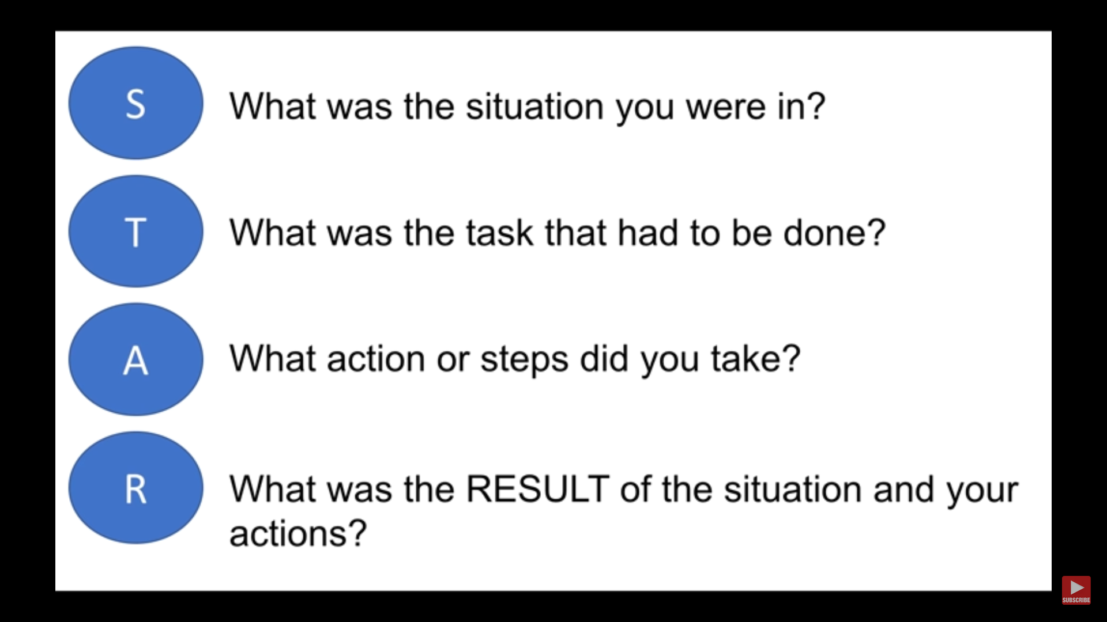

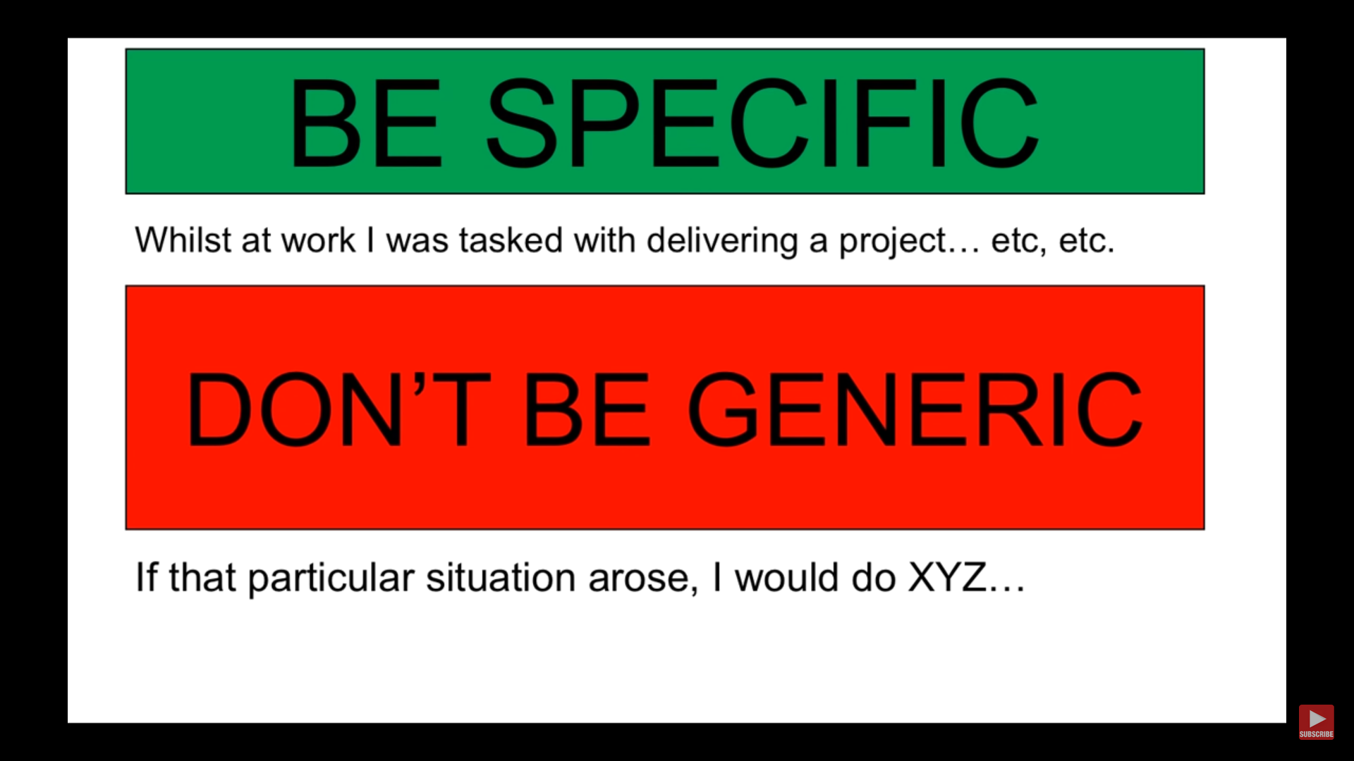

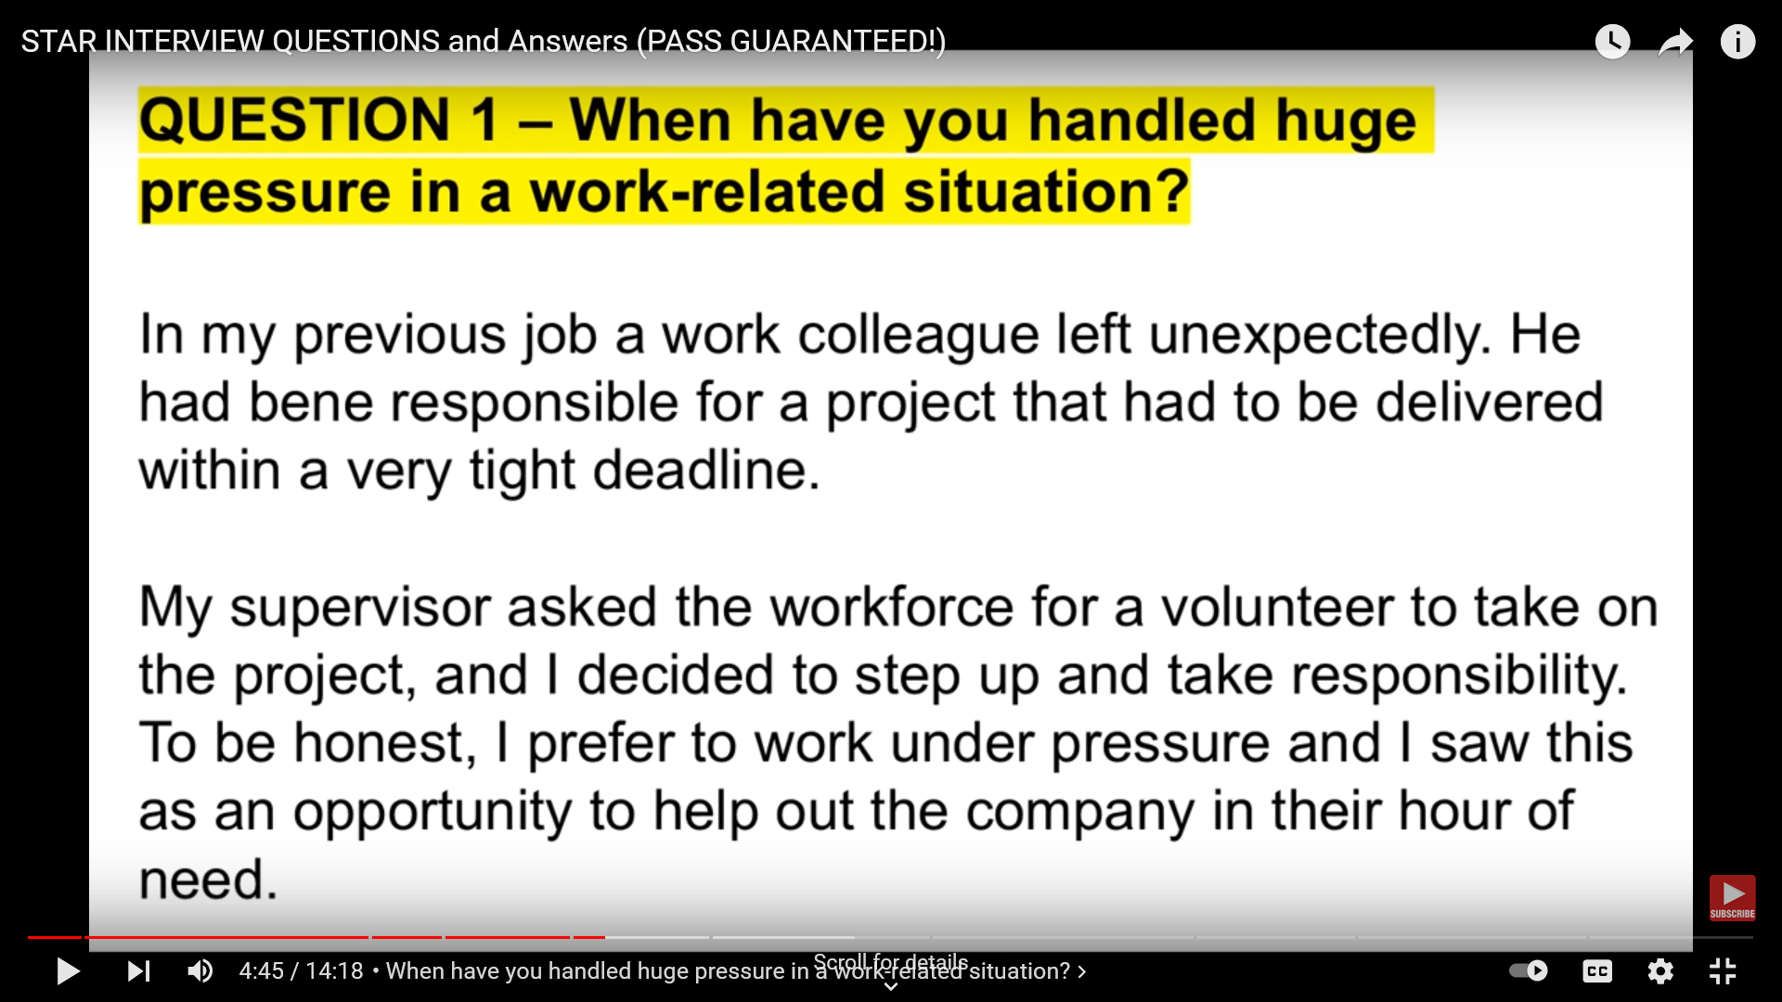

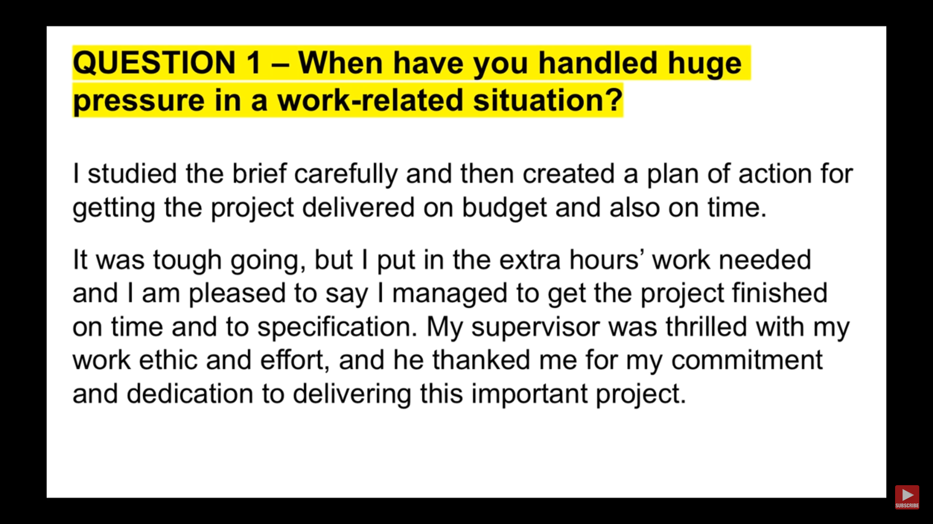

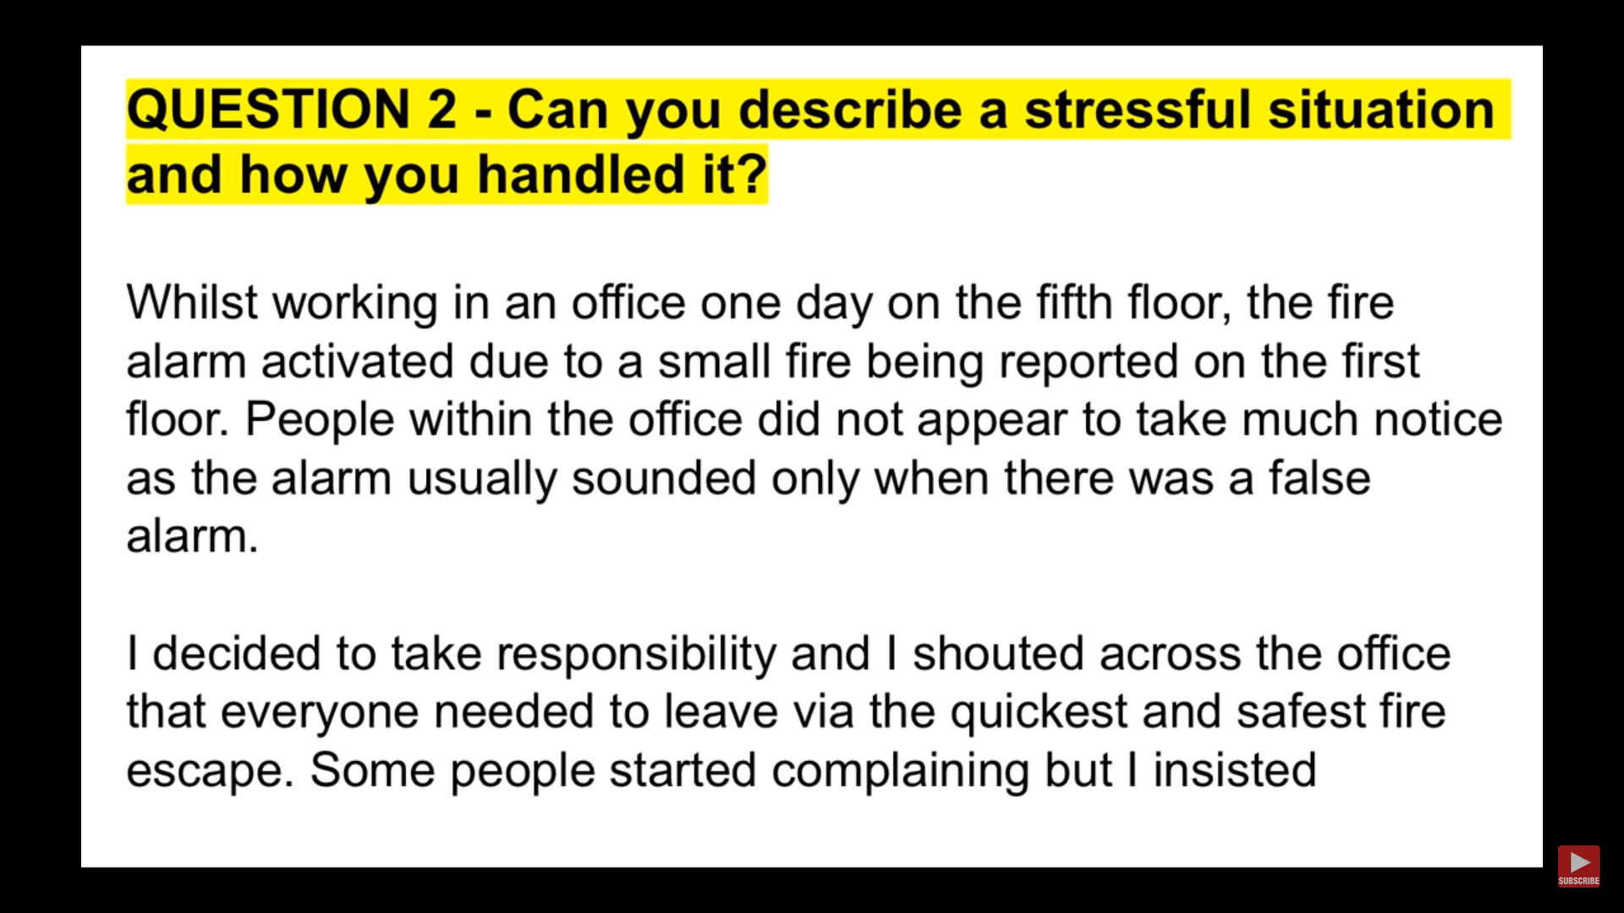

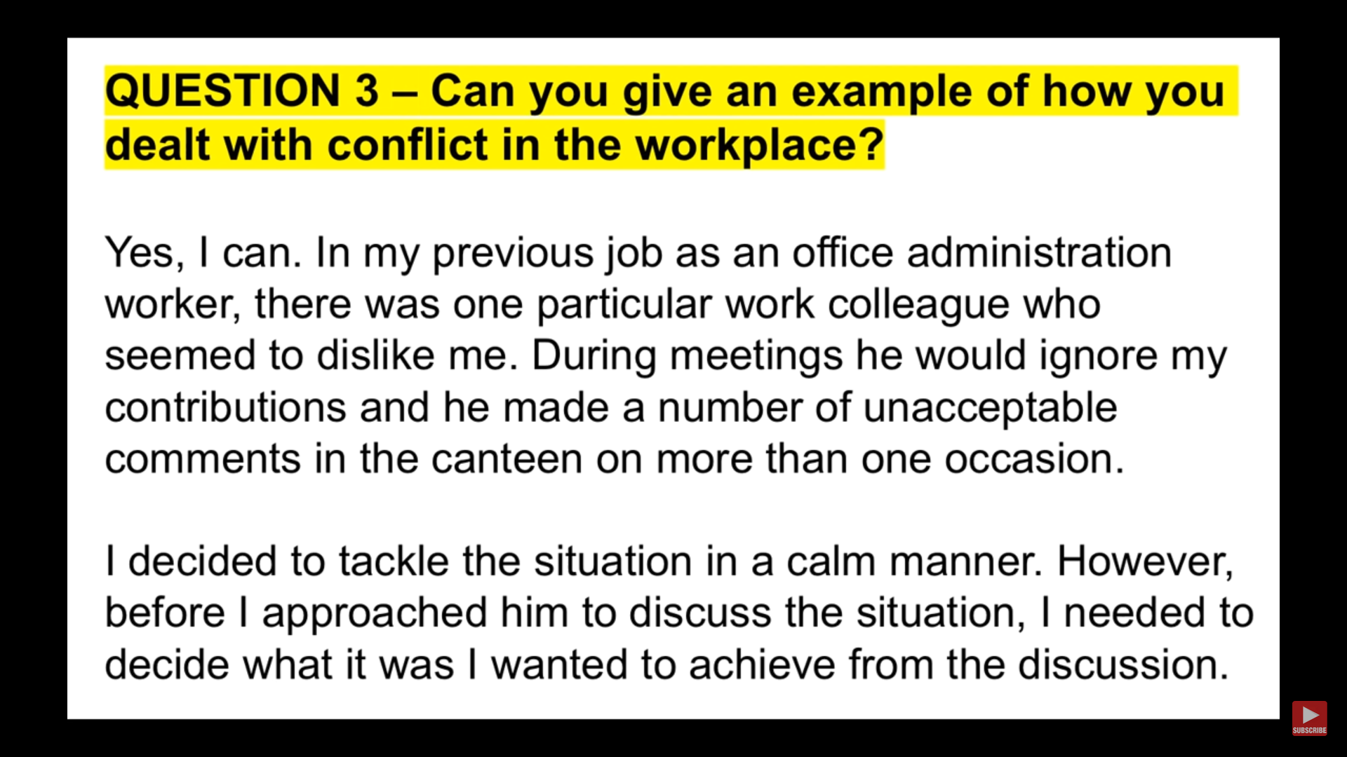

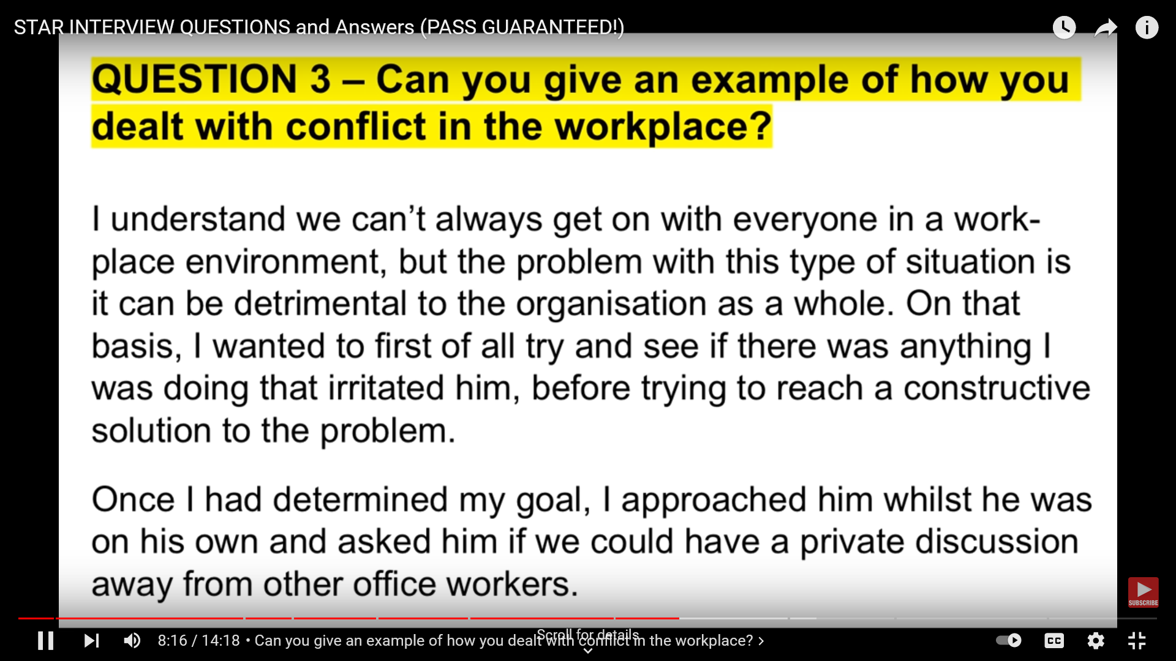

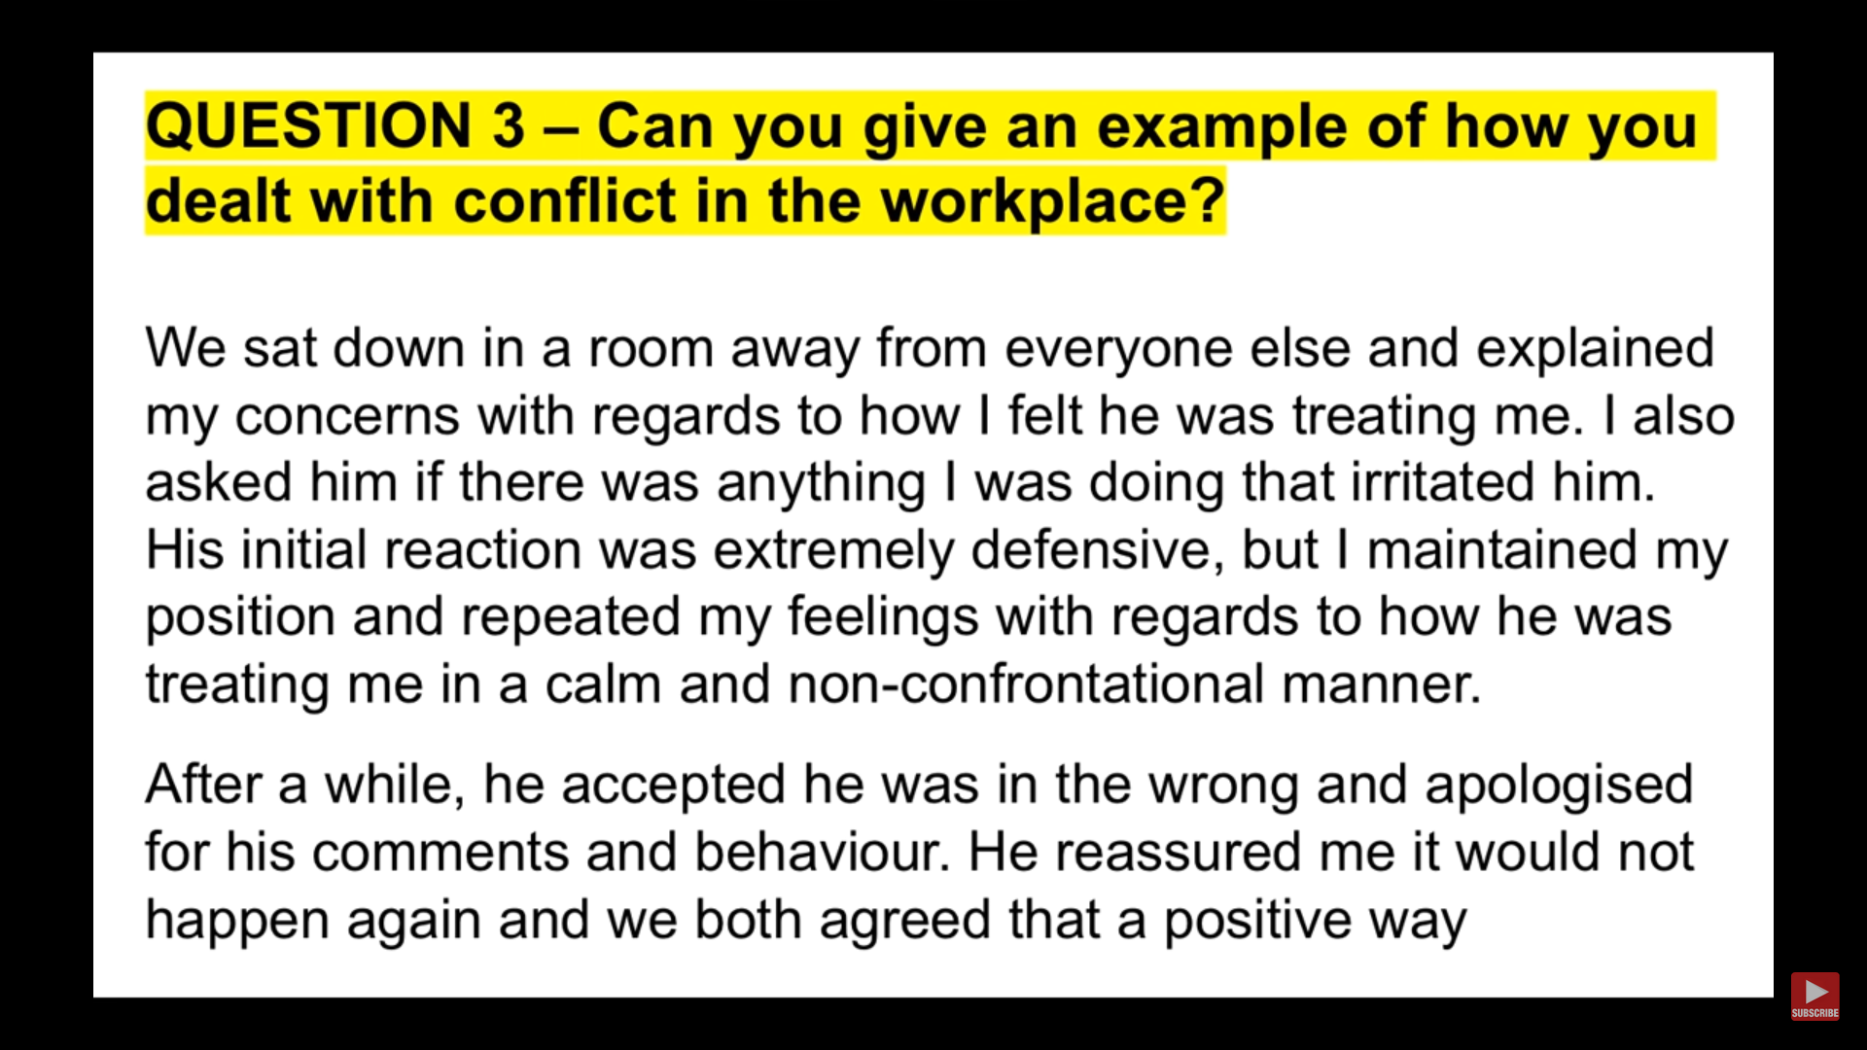

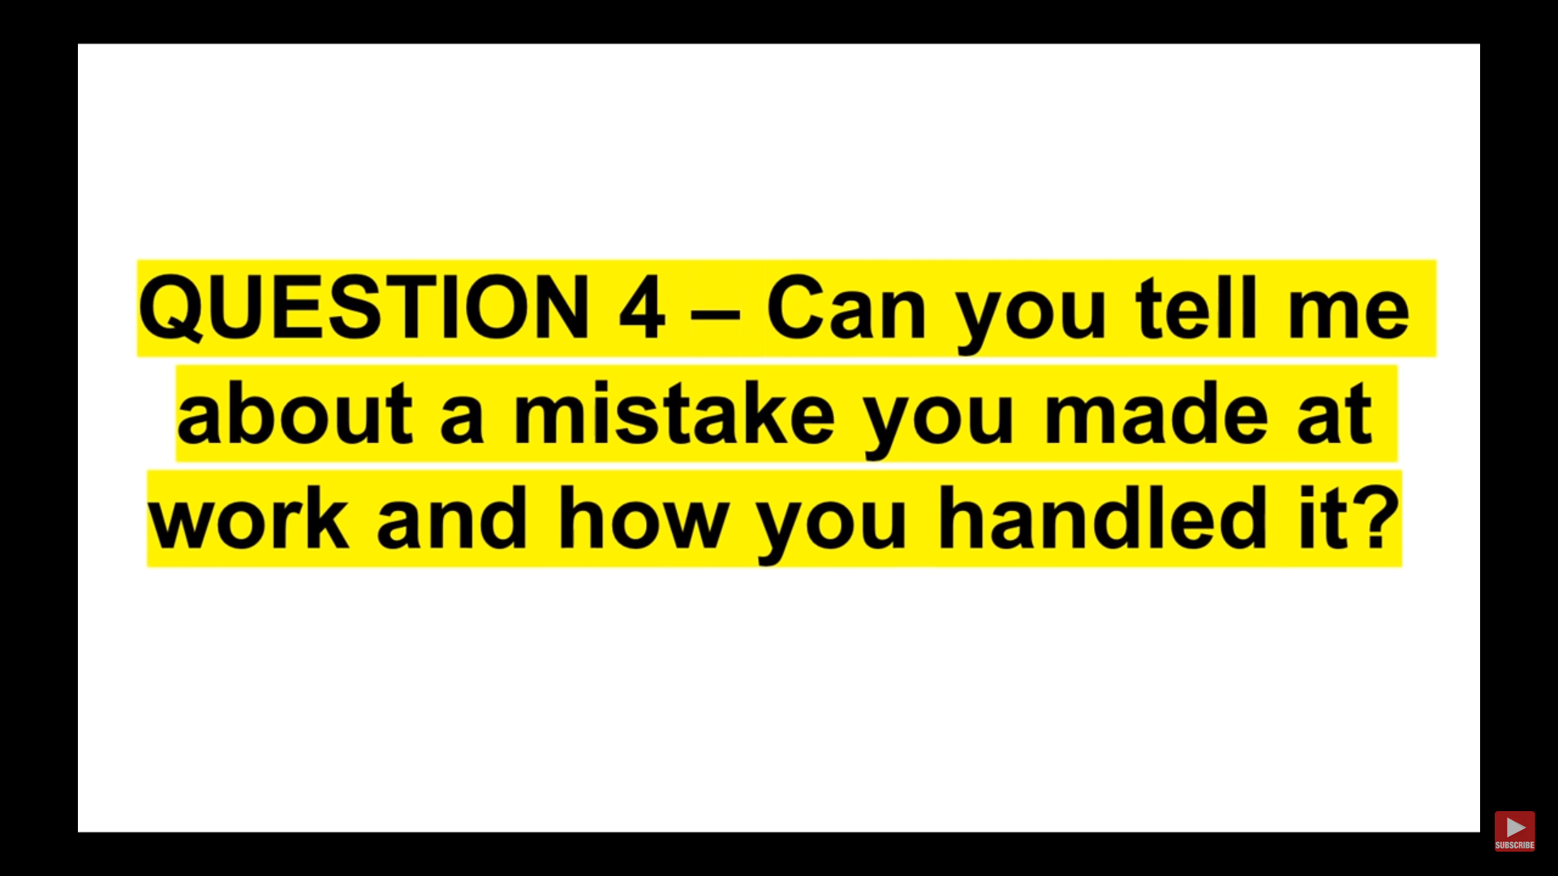

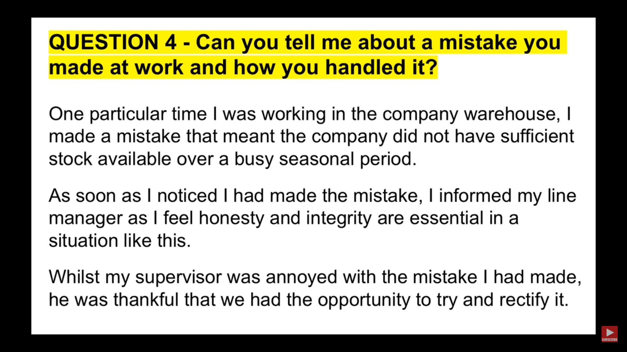

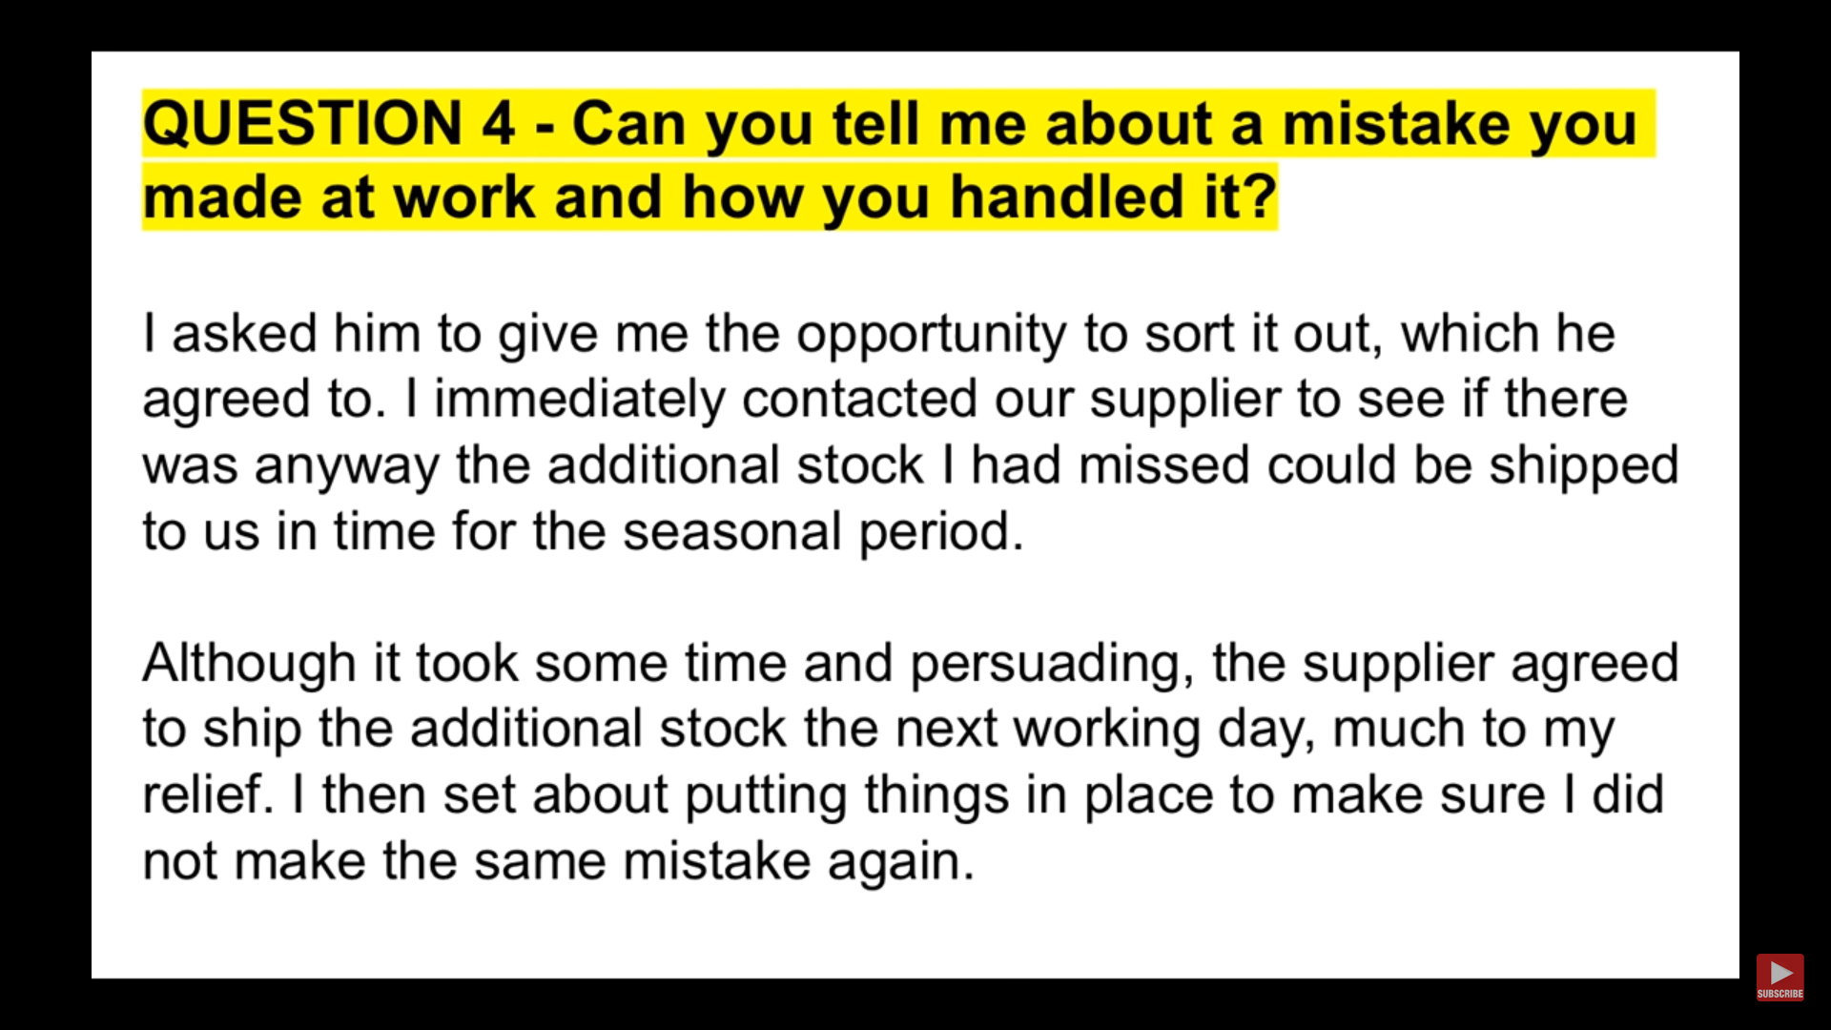

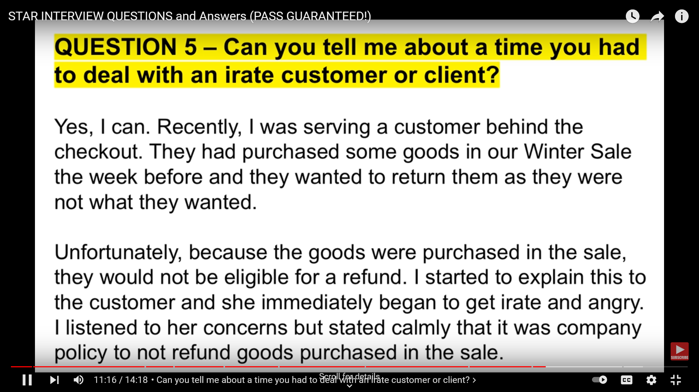

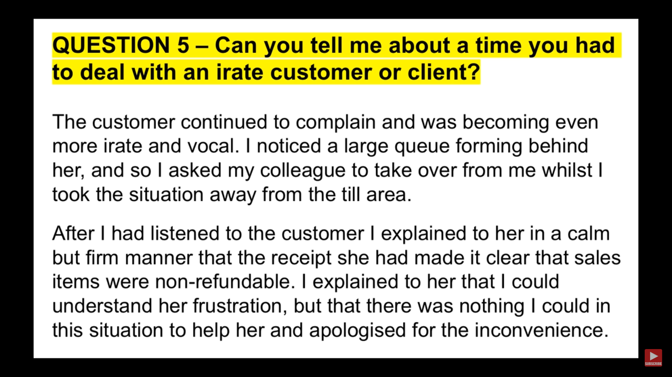

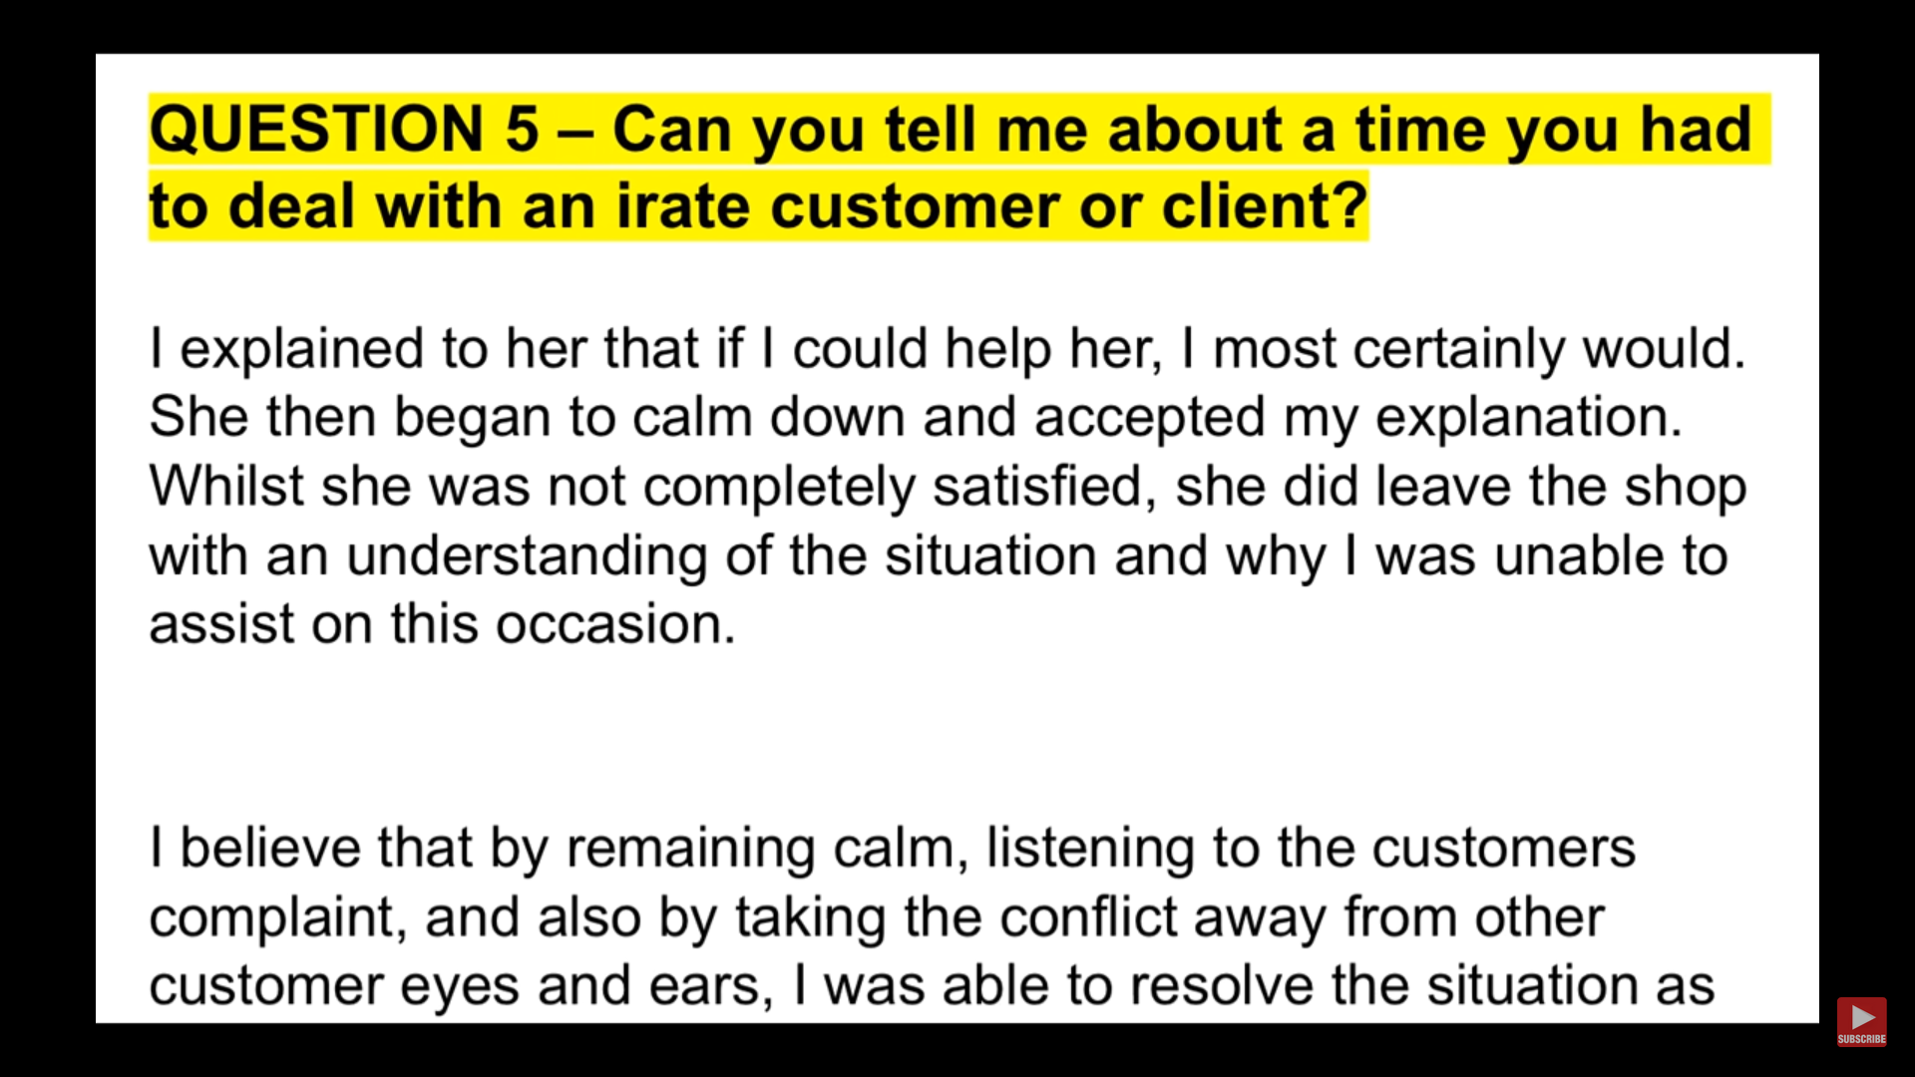

# **behavioral questions**

## What is your greatest achievement?

* From childhood only I learned to have can do attitude, always believe in myself and be generous toward another s

## **Tell me about a time when you were faced with a challenging situation. How did you solve it?**

* Senior developer to LEAD. and make it happen to delivery well

## **Do you usually set goals at work? If yes, could you give me an example of a goal you had and how you achieved it?**

## **Give me an example of a time you made a mistake at work.**

* Situation
  + In the Past I made a mistake. In our last project there were many builds environment like sandbox / dev / QA/ Beta /Prod and we had SonarQube only in dev environment to check coding standard
  + So after my work and testing in sandbox environment I deployed the code in QA environment so that that QA team can test it but as it was not run in dev environment and sonarQ tool was not run on that code which was in QA environment.
  + After releasing this I run the CICD in dev environment and sonar suggested 5 corrections to do
* Task
  + Then I was tasked to fix this and make sure it is prevented in future
* Action
  + I corrected all issue in one days only by extending my working hour and made a checklist to deploy in QA
  + So going forward any deployment in QA must be followed by prepared checklist
* Result
  + Result of that we never missed Dev Pipeline build and QA team always done QA testing on correct code base

## **Have you ever faced conflict with a coworker? How did you resolve the situation?**

**Situation**

1. Normally I am very friendly kinds of person and mingle well with all sort of employee
2. But there was time, I was working in my last and A Business Analyst was introduced in team

**Task**

1. I was tasked to work with Business Analyst to refine and understand requirement and bring it to workable state for team and map it technically. He normally did not share all the details and fact and later tell that it was also part of requirement. He also did not involve me in any requirement discussion. He also did not reply in meeting whenever asked the question that led to gap in requirement and development

**Action:**

1. I requested to have one to one talk privately and explained the scenario that due to requirement gap our team is getting delayed and it hampering project deadline and work.
   1. we established thumb rule that requirement document will be shared in advance to development team
   2. Set up a meeting and talk openly of any question
   3. Sign off of requirement document from business analyst
   4. He agreed and we become fine in all aspect.

**Result:**

1. We started to develop as per expectation and requirement and project delivered on time.

## Tell me how do you handle conflict with another co-worker.

## **Tell me about a time when you handled the pressure well.**

--- Senior Developer to Lead Journey

## **Was there a time when you had to be very strategic in order to meet a goal?**

* Microservice contract to talk to each other.
* Field and format shared

## **Give me an example of a situation when you showed initiative and took charge of a situation.**

* Last project – working o project and senior member was on holiday so I took charge of senior member role and responsibility and helped the project to proceed toward target timeline

## **Tell me about a time when you went above and beyond your duties for a job or task.**

**S:** In my last project, there was a challenge where one microservice sometime was not able to publish/send data to another microservice due to that there was a major impact. Customer was very unhappy of unstability of system and wanted fix immediately.

**T:**  I was tasked to look into it and find the root because of it and bring some design and solution for it.

**A:**  I had lots of items in my plate but I extended many ours to analyse, debug. Finally designed and developed a resilience tool using AWS serverless Lambda that re process failed event/data/ message.

**R:** As a result, application and system become stable and customer was happy. I was awarded for same.

## **Did you ever have to correct one of your superiors when they were wrong? How did you approach that situation?**

* Superior suggested to use different communication method between microservice than AWS provided
* I suggested AWS native communication service

## **Have you ever had to work under a tight deadline?**

* Show Demo to end customer

## **How do you deal with co-workers that don’t cooperate or can’t contribute enough?**

* In one of the projects, I was leading the team and one member was not contributing enough and completing the work on time
* My goal was to bring best out of him to contribute in project
* Personally talked and discussed –
  + Skill gap / domain knowledge / not able to understand requitement
* Result – able to perform

## **Tell me about a time when a client was asking for the impossible. How did you explain and communicate this to them?**

* Deprioritize + MVP+ load resource

## **Give me an example of a time when you didn’t meet a client’s expectations. How did you deal with the situation?**

## **Is there a situation you think you could’ve handled better or differently?**

## **How do you adapt to sudden changes in the workplace? Could you give me an example?**

## **What was the first job you ever had? Do you remember how you adapted and learned the ropes?**

## **Tell me about a time when you had to think on your feet in order to deal with a situation.**

## **Sometimes employers put too much on their employees’ plates. Was there a time when you were overwhelmed with work? How did you handle the situation?**

## **Tell me about a time when you had the liberty to be creative with your work. Was it exciting or difficult for you?**

## **Give me an example of a time when you and your team had opposing views on an issue. How did you persuade them to go with your decision?**

Give me an example of a time that things did not go as planned.